Pre Development Documentation

Smart CCTV-Based Weapon Detection System

Submitted By: Unknown

Date: TBD

Client / Recipient: Unknown

Table of Contents
- Executive Summary
- Problem Statement
- Proposed Solution
- Technical Architecture
- Technology Stack Justification
- Implementation Timeline
- Cost Estimation
- Risk Analysis & Mitigation
- Return on Investment (ROI)
- Appendices

1. Executive Summary
In recent years, increasing incidents of violence in public spaces such as hospitals, banks, retail stores, and educational campuses have raised significant concerns regarding public safety. Traditional CCTV systems are passive and reactive—they only provide evidence after an incident has occurred.
This proposal introduces a Smart CCTV Weapon Detection System, leveraging advanced AI-driven object detection using YOLOv8 and real-time alert mechanisms to actively identify weapons like knives and guns in surveillance footage. Upon detection, it immediately sends alerts via email and Telegram, generates audio warnings, and logs the event. This enables authorities to act within seconds, not hours.
This project aims to build an affordable, scalable, and intelligent security layer adaptable across industries.

2. Problem Statement
Traditional surveillance systems:
- Only record footage, requiring manual review
- Lack real-time analysis or notification features
- Are unable to differentiate between threats and benign behavior
- Lead to delayed response during critical events
Due to these limitations, violent incidents often escalate before any intervention can occur. An AI-driven real-time monitoring and response system is essential.

3. Proposed Solution
We propose an AI-based real-time weapon detection system that enhances existing CCTV setups with the following features:
- Weapon Detection: Detects knives, guns, and other suspect items using the YOLOv8 model
- Instant Alert System:
  - Sends detailed alerts with images and location via Email and Telegram
  - Raises voice alerts in Hindi + English
  - Plays warning sound
- Real-time Image Capturing:
  - Saves both cropped suspect image and full frame
  - GPS tagging and human-readable address
- Innocent Filtering: Sends alerts only once per unique detection, avoiding spam
- Log Management: Maintains a .CSV log of all detections
- Cool-down Mechanism: Prevents repeated alerts for the same object within 5 seconds
This modular solution runs on low-cost hardware and integrates with existing camera infrastructure.

4. Technical Architecture
Components:
- YOLOv8-based Object Detection (Python)
- OpenCV for video capture and frame processing
- Telegram API & SMTP for alert delivery
- Multithreading for parallel alert handling
- Audio playback with espeak & paplay
- CSV logging with pandas
Architecture Diagram (To Be Added):
[Placeholder for Architecture Diagram]
Workflow:
- Frame capture from CCTV
- Object detection using YOLOv8
- If weapon detected:
  - Play sound + voice alert
  - Save images (suspect + full frame)
  - Log to CSV
  - Trigger email + Telegram alert with metadata
- Apply cooldown before next alert

5. Technology Stack Justification
Component | Choice | Reason
Object Detection | YOLOv8 | High-speed, accurate, lightweight
Language | Python | Readable, flexible, rich libraries
Messaging | Telegram API | Fast, free, rich media support
Alerts | Gmail SMTP | Widely used, easy to configure
GUI (Optional) | Flask / Streamlit | For admin panel and monitoring

6. Implementation Timeline
Week | Milestone
Week 1 | Requirement Finalization, Planning
Week 2 | Model Training and Initial Testing
Week 3 | Real-Time CCTV Integration
Week 4 | Alert System Integration (Email + Telegram)
Week 5 | Logging and Cooldown Mechanism
Week 6 | Testing, Optimization, Bug Fixing
Week 7 | Deployment & Field Testing
Week 8 | Final Delivery & Training

7. Cost Estimation (Reduced)
Component | Estimated Cost (INR)
Hardware Setup (CCTV + Mini PC) | ₹20,000
Development & Integration | ₹25,000
Deployment + Testing | ₹10,000
Maintenance & Support (6 months) | ₹10,000
Miscellaneous & Internet Charges | ₹5,000
Total Estimated Budget | ₹70,000 – ₹85,000
Note: Cost can be reduced further if existing cameras and internet are available.

8. Risk Analysis & Mitigation
Risk | Likelihood | Impact | Mitigation Strategy
False Positives | Medium | Medium | Improve dataset, filter by object confidence
Hardware Failure | Low | High | Use UPS, test hardware regularly
Network Delay | Medium | High | Offline logging, retry logic for alerts
Model Errors | Low | Medium | Update YOLO model periodically
Privacy Concerns | Medium | Medium | Store logs securely, encrypt alerts

9. Return on Investment (ROI)
Investing in this system provides:
- 24x7 active monitoring at lower cost
- Quick incident response
- Reduced loss due to theft/violence
- Enhanced brand reputation (especially in hospitals, schools)
- Automation reduces the need for constant manual surveillance
Compared to hiring additional security or responding post-incident, this system delivers faster action, lower cost, and long-term value.

10. Appendices

A. Sample Detection Log Entry
Timestamp: 2025-08-04 16:12:15
Detected: Knife
Suspects: 1
Address: Jaipur, MI Road, Shop #22
Map: https://maps.google.com/?q=26.9124,75.7873

B. Sample Email Alert (Text)
Subject: 🔴 Suspect Object Detected!
Body:
📅 Date & Time: 2025-08-04_16-12-15
️ Suspect Items: Knife
 Location: Jaipur, MI Road, Shop #22
 Google Map: https://maps.google.com/?q=26.9124,75.7873

C. Screenshots & Visual Output
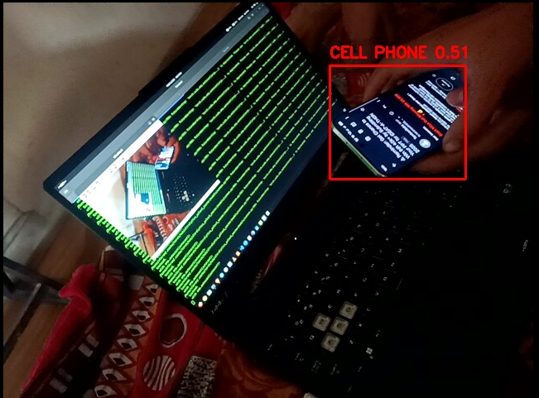
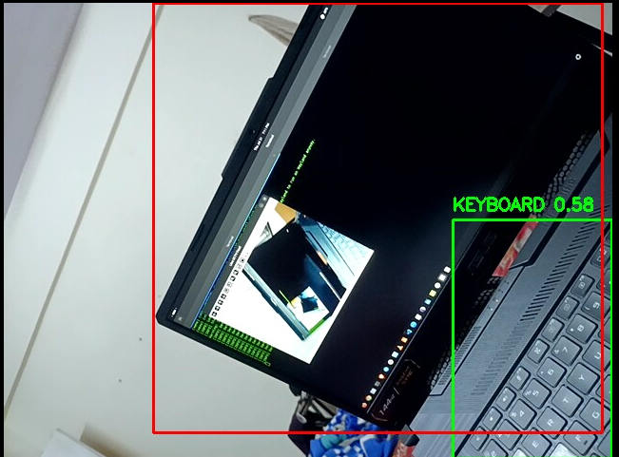
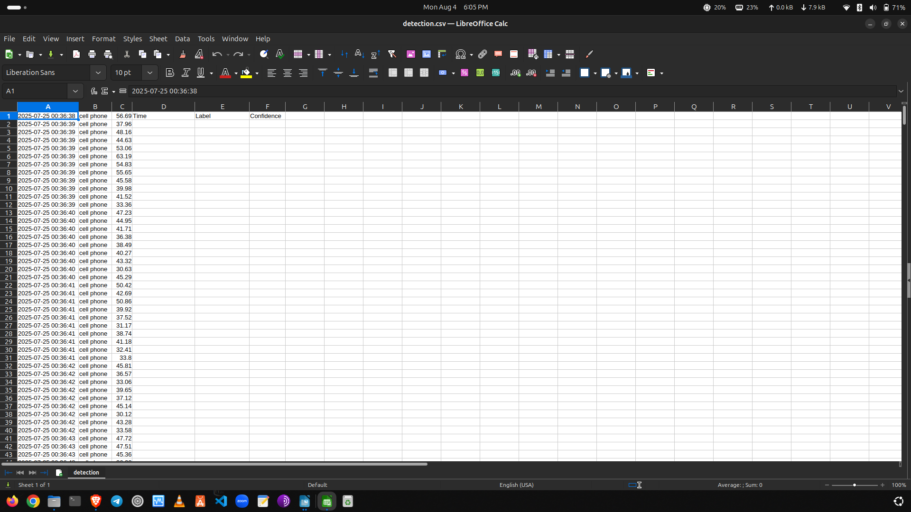

Prepared by:
Contact Info:

